INVESTMENT RESEARCH AND STRATEGY TEAM
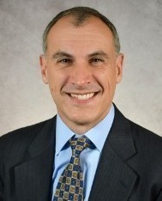
Marc Balcer
Senior Vice President and Director, Investment Strategy
Girard Advisory Services, LLC

Contact Marc Balcer
As the director of investment strategy, Marc partners with Girard's advisors to provide clients and prospects guidance on the appropriate investment tools and strategies to help achieve their financial goals while aligning with their values. He has more than 15 years of experience in the financial services industry. Previously, he was co-founder and portfolio manager at Bluefin Investment Management, a long-short equity hedge fund. Most recently, he coached and taught social-emotional learning at The Shipley School.
He received a bachelor’s degree in economics and growth and structure from Haverford College and a master’s degree in nonprofit leadership from the University of Pennsylvania. He also earned the CFA Charterholder designation in 2000. Marc is active in his local community and currently serves on the external relations and audit committees for The Woodlynde School, a K-12 college prep school for students with learning differences. In addition, he serves as a mentor for both CFA of Philadelphia’s Inve$t in Her Future and Clarifi’s financial counseling programs. When he’s not working or volunteering, he enjoys spending time with his family. He is also a huge fan of stand-up comedy and enjoys teaching mindfulness and meditation with a particular focus on men, middle age and the workplace. Marc resides in Wayne, Pa. with his wife and children.

