Jessica Jones, BSW
Area Agency on Aging Director

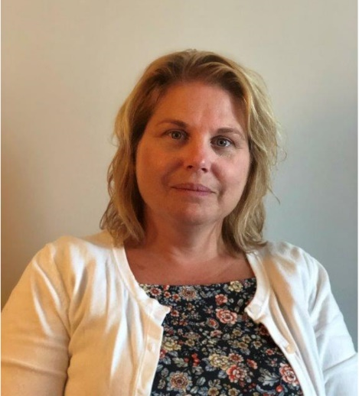
Jessica leads the Berks County Area Agency on Aging as Director since December 2020. Previous she served as Deputy Director over 6 years. In these roles her responsibilities include the oversight and the planning, delivery and monitoring of approximately 9.7 million dollars of public funds serving the aging service needs of approximately 75,000 county residents.

Jessica’s passion and much of her career focus has been the investigation of elder abuse in all care settings to protect our most fragile community members. Her vast experience includes nursing facilities, in-home long-term care supports & services, care management and supervision. Jessica also has numerous years of experience in guardianship coordination.

As Director, Jessica has focused on the Agency’s mission to serve the older adults of Berks County always seeking to improve on the agency’s coordination of services.

Due to her vast knowledge of aging services Jessica is often requested for speaking engagements and trainings.

Jessica received her bachelor’s in social work at Kutztown University. With over 20 years of experience in Older Adult Protective Services she maintains her certification in Protective Services and actively assists in continual development of the statewide program through the Aging Network in Pennsylvania.

PROFESSIONAL EXPERIENCE

Area Agency on Aging Director
County of Berks, PA
December 2020 – present

Area Agency on Aging Deputy Director
County of Berks, PA
March 2014 – December 2020

Area Agency on Aging Protective Services Supervisor
County of Berks, PA
March 2014 – present

EDUCATION

Bachelor’s degree | Social Work | Kutztown University | Kutztown, PA

Long-term Institute of PA LDI Graduate, June 2014

PROFESSIONAL/COMMUNITY AFFILIATIONS

P4A Board, Member

PA Cultural Diversity Advisory Council, Member

BARTA Advisory Committee,
Member

Threshold Rights Committee,
Member

Criminal Justice Advisory Board (CJAB), Member

OPIOID Task Force, Member

Berks County Elder Abuse Task Force, Member

CONTACT
jjones@countyofberks.com
610-823-0276

