Sponsor Form
https://www.berkscountyepc.org/

Company Name

_________________________________________________________________________________________

Contact Name_____________________________________________________________________________

Contact Phone______________________________________________________________________________

Contact E-mail______________________________________________________________________________

EPC Objectives
- Foster intelligent cooperation and cordial understanding among persons in the field of estate planning.

- Provide information having to do with effective and efficient estate planning.

- Promulgate proper ethical standards in the field of estate planning.

- Assist members in keeping abreast of laws and regulations effecting estate accumulation and conservation.
Presenting Sponsorship of $300 includes:

- “5-10 minute” segment during your “sponsored event”

- One free guest

- Table provided for promotional materials.

- Sponsor listed on EPC website and all meeting announcements.

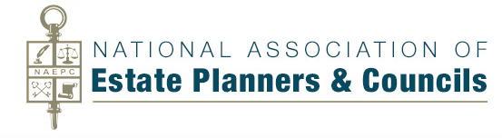
Affiliated with
CONTACT INFORMATION
Vivi Anthony, EPC Administrator
Berks County Community Foundation
237 Court Street, Reading, PA 19601
Phone: 610.685.2225 | vivia@bccf.org

